**A Fast-Particle Based Approach to Calibrate the Distributed Hydrologic Model**

Sanjib Sharma1*, Benjamin Seiyon Lee2, Iman Hosseini-Shakib1, Murali Haran3, Klaus Keller1,4

1Earth and Environmental Systems Institute, The Pennsylvania State University, University Park, PA, USA

2Department of Statistics, The George Mason University, Fairfax, VA, USA

3Department of Statistics, The Pennsylvania State University, University Park, PA, USA

4Department of Geosciences, The Pennsylvania State University, University Park, PA, USA

*Corresponding author (sanjibsharma66@gmail.com)

Projected Submission on Water Resources Research

Projected Submission deadline: November 30, 2021

**Key points**

* Current approaches to characterize flood hazards often sample only a relatively small subset of the known unknowns such as hydrologic model parameters.
* We implement a sequential Monte Carlo particle-based approach to fully characterize the hydromodel parametric uncertainty.
* Accounting model parametric uncertainty improves flood calibration and predictions.

**Keywords**

Hydromodel calibration, particle-based approach,

uncertainty characterization, Flood hazards

**Abstract**

Floods drive dynamic and deeply uncertain risks for people and infrastructures.  Uncertainty characterization is a crucial step in improving the predictive understanding of multi-sector dynamics and the design of risk management strategies.  Current approaches to estimate flood hazards often sample only a relatively small subset of the known unknowns such as model parameters. This approach neglects the impacts of key uncertainties on hazards and dynamics, can drastically underestimate the tails of flood hazard probability distribution, and can result in poor decisions and outcomes. Here we assess whether and how a sequential Monte Carlo method can improve model hindcasts and predictions. Specifically, we deploy a particle-based approach that takes advantage of the massive parallelization afforded by modern high-performance computing systems. Overall, our results reveal that accounting model parametric uncertainty improves flood hazard estimates over traditional calibration approaches such as stepwise manual calibration and precalibration.

**1. Introduction**

Floods pose major risks to people and property [(Winsemius *et al.*, 2015; Alfieri *et al.*, 2017; Wing *et al.*, 2018)](https://paperpile.com/c/6WVc5S/DHF4+CfaN+zsdZ). These risks are dynamic and deeply uncertain. It is important to characterize the uncertainties surrounding flood hazards to understand multi-sector dynamics and to inform the design of risk management strategies [(Wong and Keller, 2017; Liu and Merwade, 2018; Salas, Obeysekera and Vogel, 2018; Chester, Shane Underwood, and Samaras, 2020; Wasko *et al.*, 2021)](https://paperpile.com/c/6WVc5S/RlGw+NhG6+ADlI+cYRD+fXxL).

Current approaches to estimate flood hazards often sample only a relatively small subset of the known unknowns such as model parameters ​[(Feng *et al.*, 2018; Judi *et al.*, 2018; Wing *et al.*, 2018; Pralle, 2019; Sanders *et al.*, 2020; Bates *et al.*, 2021)](https://paperpile.com/c/6WVc5S/2nWV+oOe2+Zzin+2U4o+CfaN+UuqS)​. This neglects the impacts of key uncertainties on hazards and dynamics, can drastically underestimate the tails of flood hazard probability distribution, and result in poor decisions and outcomes [(Wong *et al.*, 2018; Ruckert, Srikrishnan and Keller, 2019; Zarekarizi, Srikrishnan and Keller, 2020)](https://paperpile.com/c/6WVc5S/kn1j+7jl9+8gav).

Traditional approaches to hydrodynamic model calibration typically rely on manually adjusting a subset of model parameters [(Mizukami *et al.*, no date; Koren *et al.*, 2004; Thorstensen *et al.*, 2016; Judi *et al.*, 2018; Brunner *et al.*, 2020; Rajib *et al.*, 2020; Bates *et al.*, 2021)](https://paperpile.com/c/6WVc5S/Zzin+UuqS+5y15+39Dx+QDvi+GBY7+AqLL), and/or surrogate methods such as Gaussian process-based emulators to provide best-fit parameter sets [(Koren *et al.*, 2004; Pianosi *et al.*, 2016; Gou *et al.*, 2020)](https://paperpile.com/c/6WVc5S/vfvW+cX7k+GBY7)​​. Recently, Gou et al. (2020) developed an automatic calibration framework that combines sensitivity analysis and surrogate-based optimization for calibrating catchment-specific hydrologic model parameters. These approaches typically neglect the high dimensionality of hydrodynamic models or are computationally impractical because they require too many model runs and/or too much computational resources.

Previous studies have provided important new insights on Bayesian statistical inference for hydrologic model calibration [(Tang *et al.*, 2007; Jeremiah *et al.*, 2011; Shafii, Tolson and Shawn Matott, 2015; Su *et al.*, 2018; Zhu *et al.*, 2018)](https://paperpile.com/c/6WVc5S/2Cjx+lDTz+fbzu+By1z+KTZH)…

To tackle the model calibration challenge, we assess the efficiency of a sequential Monte Carlo method. We deploy a particle-based approach [(Lee *et al.*, 2020)](https://paperpile.com/c/6WVc5S/u8Qp)​ for hydromodel calibration that takes advantage of the massive parallelization afforded by modern high-performance computing systems.

We choose Selinsgrove, PA as a test case where frequent and severe floods are a major concern. This study focuses on a key question: What are the effects of accounting model parametric uncertainty in flood calibration and out-of-sample predictions?

**2. Results**

**3. Methods**

**3.1. Data**

We use three main observation datasets: multisensor precipitation estimates (MPEs), gridded near-surface air temperature, and daily streamflow. MPEs and gridded near-surface air temperature are used to run the hydrological model in simulation mode for parameter calibration purposes and to initialize the hydrological model. Both the MPEs and gridded near-surface air temperature data at 4 × 4 km2 resolution were provided by the NOAA's Middle Atlantic River Forecast Center. The MPEs represent a continuous time series of hourly, gridded precipitation observations at 4 × 4 km2 cells, which are produced by combining multiple radar estimates and rain gauge measurements. The gridded near-surface air temperature data at 4 × 4 km2 resolution were developed by combining multiple temperature observation networks. Daily streamflow observations for the selected basins were obtained from the United States Geological Survey (USGS 01554000).

**3.2. Distributed Hydrological Model**

We use the National Oceanic and Atmospheric Administration's Hydrology Laboratory-Research Distributed Hydrologic Model (HL-RDHM). HL-RDHM is used as the spatially distributed hydrological model. Within HL-RDHM, we deploy the Sacramento Soil Moisture Accounting model with Heat Transfer to represent hillslope runoff generation, and the SNOW-17 module to represent snow accumulation and melting. In this study, we run HL-RDHM using a 2 km horizontal resolution.

HL-RDHM is a spatially distributed conceptual model, where the basin system is divided into regularly spaced, square grid cells to account for spatial heterogeneity. Each grid cell acts as a hillslope capable of generating surface, interflow, and groundwater runoff that discharges directly into the streams. The cells are connected to each other through the stream network system. Further, the SNOW-17 module allows each cell to accumulate snow and generate hillslope snowmelt based on the near-surface air temperature. The hillslope runoff, generated at each grid cell by SAC-HT and SNOW-17, is routed to the stream network using a nonlinear kinematic wave algorithm. Likewise, flows in the stream network are routed downstream using a nonlinear kinematic wave algorithm that accounts for parameterized stream cross-section shapes.

**3.3. Model Parameters and Priors**

ADD BLURB ABOUT MODEL PARAMETERS

We specify univariate uniform prior distributions for all 12 model parameters. For each uniform prior distribution, we impose lower and upper bounds (i.e. the hyperparameters) specified by our hydrological model experts (Table XX) For the combined error variance parameter, we designate an inverse gamma prior with hyperparameters scale $α_{σ }=0.2$ and shape $β_{σ}=0.2$.

|  |  |  |
| --- | --- | --- |
| **Parameter $θ_{j}$** | **Lower Bound $l_{j}$** | **Upper Bound $u_{j}$** |
| PCTIM | 0 | 5 |
| ADIMP | 0 | 2 |
| UZTWM | -50 | -0.1 |
| LZTWM | -70 | -0.1 |
| LZFSM | -100 | -0.1 |
| LZFPM | -100 | -0.1 |
| LZSK | -3.8 | -0.1 |
| snow SCF | 0.5 | 1.5 |
| REXP | -3.5 | -0.1 |
| UZK | -3.5 | -0.1 |
| Q0CHN | 0.5 | 4.5 |

**Table XX. Hyperparameters (lower and upper bounds) for the uniform prior distributions of the model parameters.**

**3.4. Calibration**

In computer model calibration, we estimate key computer model parameters by comparing the model output to the observational data (cf. Chang et al., 2016; Kennedy and O’Hagan, 2001; Bayarri et al., 2007; Bhat et al., 2010). Calibration methods can also account for important sources of uncertainty attributed to the model-observation discrepancy and observational errors (Kennedy and O’Hagan, 2001; Bayarri et al., 2007; Brynjarsdottir and O’Hagan, 2014), as well as uncertainty in the model projections (Chang et al., 2016, Lee et al., 2020).

**I. Bayesian Calibration Framework**

Suppose we have an observed times series (e.g. daily streamflow in mm) obtained for a distinct time interval (e.g. January 1, 2004 – December 31, 2005) at some location. In addition, we have a computer model (e.g. HL-RDHM) that models the underlying dynamic processes and generates a time series that is comparable to the observations. To generate the computer model output, we must provide a set of input parameters and forcings (e.g. daily precipitation levels). We aim to find the input settings whose corresponding model outputs best resemble the observations.

In computer model calibration, the objective is two-fold: (1) infer the input parameters (i.e. point estimates); and (2) quantify the uncertainty underlying the estimated input parameters (i.e. interval estimates). Other sources of uncertainty such as model-observation discrepancy (Kennedy and O’Hagan, 2001; Bayarri et al., 2007; Brynjarsdottir and O’Hagan, 2014) and measurement errors may directly influence parameter estimation. The Bayesian computer model calibration framework (Kennedy and O’Hagan, 2001) facilitates both parameter estimation and uncertainty quantification while also accounting for external sources of uncertainty (e.g. discrepancy and measurement errors). Here, the parameter inference follows from the posterior distribution of the model parameters given the observed data.

For complex deterministic computer models, the posterior distribution may not be available in closed form [ADD REFERENCES]; hence, we must approximate the posterior via sampling methods such as Markov chain Monte Carlo (MCMC) or Sequential Monte Carlo methods.

* Markov chain Monte Carlo methods are appropriate for computer models with short single model run times (less than three seconds).
* Emulation-calibration approaches replace the computer model with a faster surrogate model, or emulator, and then proceed to approximate the posterior distribution using MCMC. However, emulation-calibration methods tend to be limited to computer models with few model parameters (less than 5).
* Sequential Monte Carlo

In this study, we focus on the

In addition to the 12-parameter calibration, we implement three competing calibration approaches and compare the respective results: (1) a hand-tuned estimate of the `best'' parameter settings (sequential calibration); (2) a precalibration screening method; and (3) the fast particle-based approach limited to four parameters. Sequential calibration fixes the computer model parameters at the “best guess” values suggested by domain-area experts; hence, it does not account for parametric uncertainty. The precalibration approach applies a screening criterion to a large ensemble of computer model runs and removes the model runs that do not align with the observed data. The remaining model runs and their corresponding parameter sets will approximate the desired posterior and posterior predictive distributions. The low-dimensional calibration approach infers four key model parameters (PCTIM, ADIMP, Q0CHN, and QMCHN) and fixes the remaining seven parameters, typically at the hand-tuned values (sequential calibration). We chose to omit a comparison to emulation-calibration approach as an internal sensitivity test revealed that the resulting surrogate model (Gaussian process emulator) did not represent the true model. Please see supplement for additional details.

i. Sequential calibration

To calibrate HL-RHDM, we first run the model using a priori parameter estimates previously derived from available datasets. We then select 12 out of the 17 SAC-HT parameters for calibration based upon prior experience and preliminary sensitivity tests. The model parameters are adjusted manually first; once the manual changes do not yield noticeable improvements in model performance, the model is calibrated using precalibration and FAMOS.

ii. Precalibration

The precalibration approach applies a screening criterion to a large initial ensemble of computer model runs; thereby removing model runs whose outputs do not resemble the observed data. The remaining model runs and their corresponding parameter sets will approximate the desired posterior and posterior predictive distributions. We begin with an initial ensemble of 5,000 model runs with input parameters settings selected from a 12-dimensional Latin hypercube design. From the initial ensemble, we select a subset of 165 runs that fulfills the following screening criteria: (1) hydrological model output (streamflow) at each observation date must be greater than 25% of the observed streamflow; and (2) hydrological model output (streamflow) at each observation date must be less than 175% of the observed streamflow. We extract the corresponding parameter values and outputs to construct Figures 3 - 7.

iii.Famos

In this study, we calibrate the HL- RDHM computer model using the fast particle-based approach (Lee et al., 2020) due to moderately long single-model run times (15 minutes) and large number of variable parameters (11).

**2.5. Evaluation Metrics**

**Acknowledgments**

This study was co-supported by the US Department of Energy, Office of Science through the Program on Coupled Human and Earth Systems (PCHES) under DOE Cooperative Agreement No. DE-SC0016162 as well as the Penn State Center for Climate Risk Management. We thank Rob Nicholas, Skip Wishbone, Dave Judi, and the PSIRC team for inputs. All errors and opinions (unless cited) are those of the authors and not of the funding entities.

**Disclaimer and License**

The results, data, software tools, and other resources related to this work will be available under the GNU general public open-source license, as-is, without warranty of any kind, expressed or implied. In no event shall the authors or copyright holders be liable for any claim, damages, or other liability in connection with the use of these resources. This is academic research and not designed to be used to guide a specific decision.

**Author contributions**

All authors contributed to the study design. S.S. led the hydrologic analysis. B.L. constructed the particle-based calibration model. S.S. and B.L. led the calculations. I.S. performed a code review and edited the paper. S.S., B.L, and K.K wrote the initial draft of the manuscript. All authors revised and edited the manuscript.

**Data and Code Availability**

The code used for this analysis and the data required to plot the results will be available through a publically accessible GitHub repository and under the GNU open-access license after acceptance in a peer-reviewed journal.

**Competing interests**

The authors are not aware of any competing financial or nonfinancial interests.

**Materials & Correspondence**

Correspondence and requests for materials should be addressed to the corresponding author.

**Figures**

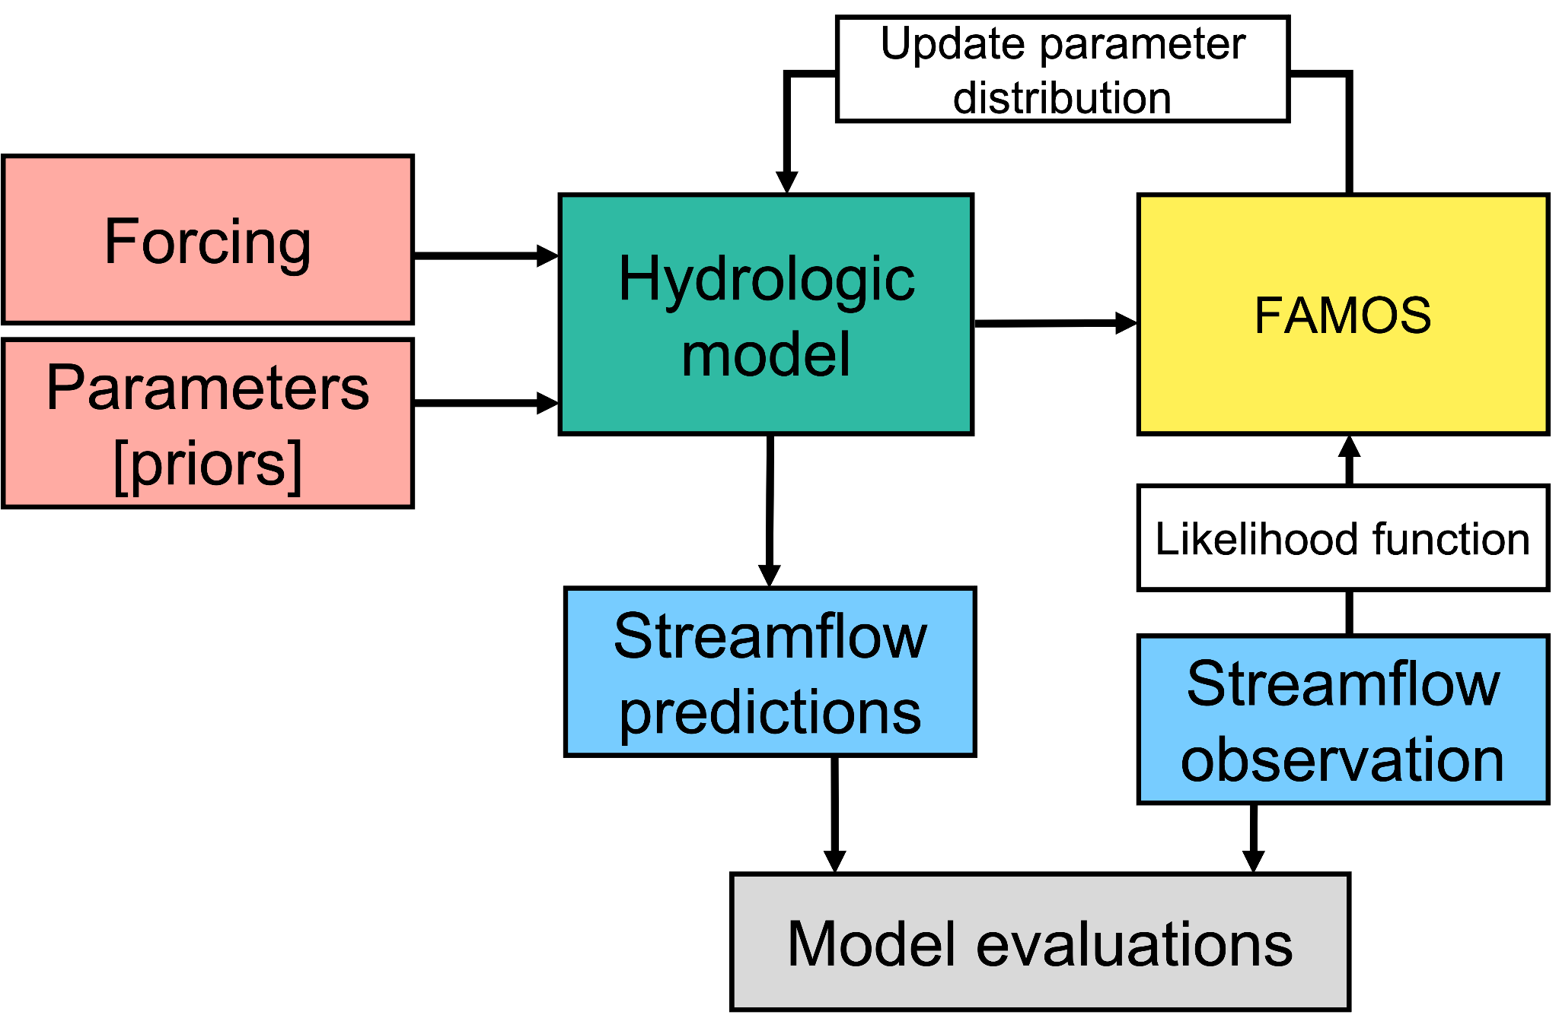

Figure 1: Diagrammatic representation of hydrological model calibration framework.

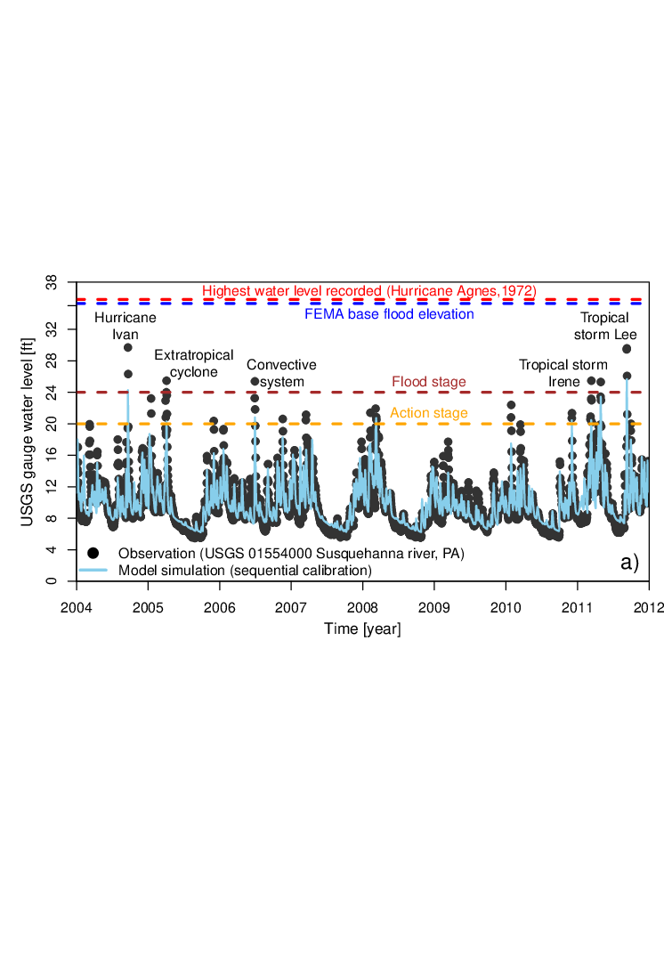

**Figure 2:** Historical time series of water level observation and model simulations obtained using sequential model calibration. We obtain the observation from the United States Geological Survey (USGS) gauge records for ID 01554000 located upstream of Selinsgrove, Pennsylvania, USA.

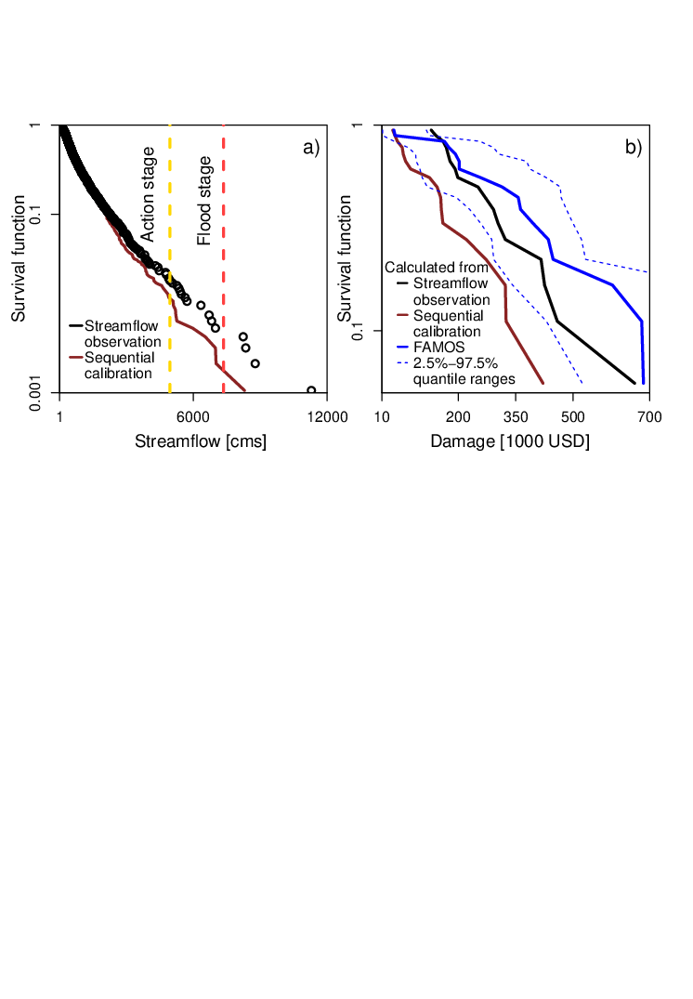

**Figure 3:** Survival function for a) streamflow observation and model simulations obtained using sequential calibration; b) damage estimates using streamflow observations and model simulations obtained using sequential calibration and FAMOS.

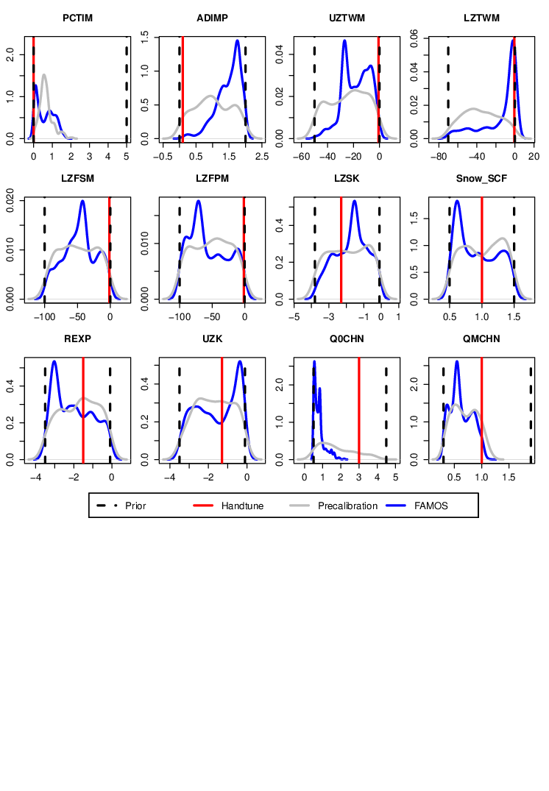

**Figure 4:** Prior and posterior distribution of hydrological model parameters.

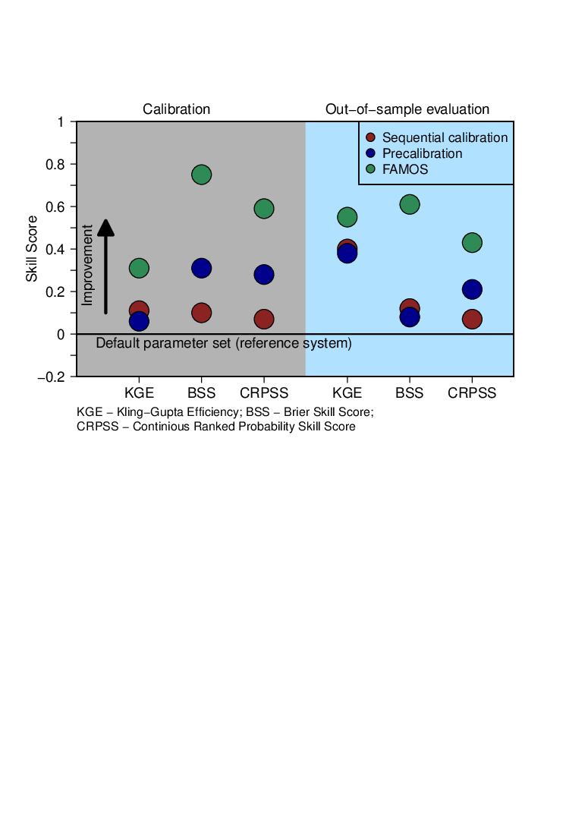

**Figure 5:** Performance metrics for hydrological model calibration and out-of-sample prediction. We compute Klinge-Gupta Efficiency (KGE), and Brier skill score (BSS), and Continuous ranked probability skill score (CRPSS). All the metrics are computed with reference to the default parameter set. Any positive values of the skill score, from 0 to 1, indicate that the calibration approach performs better than the reference system. Thus, a skill score of 0 indicates no skill, and a skill of 1 indicates perfect skill.

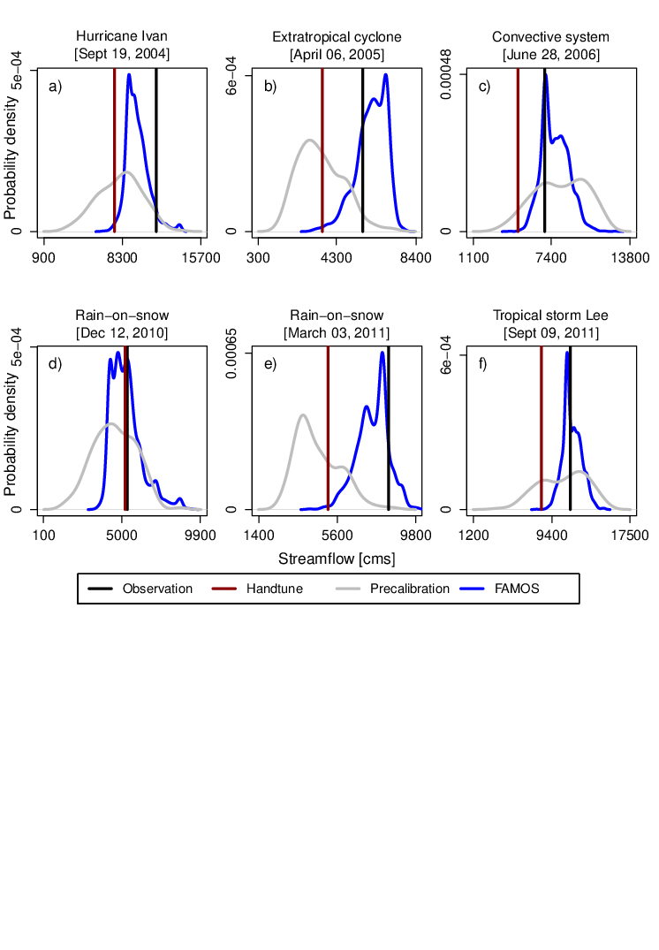

**Figure 6:** (a) - (c) Calibration and (d) - (f) and out-of-sample prediction for different flood events.

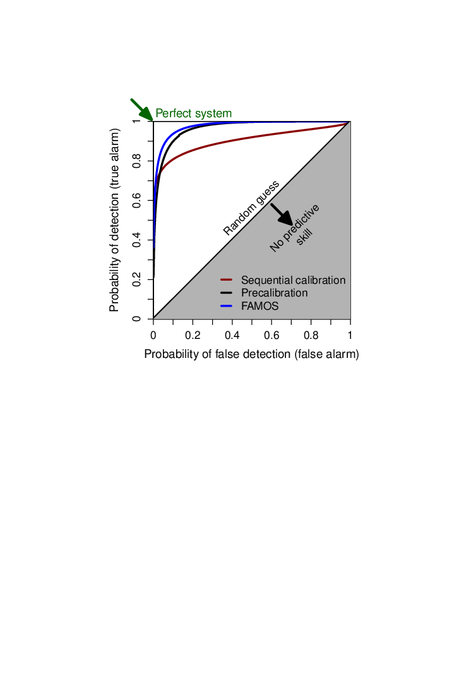

**Figure 7:** Prediction ability to discriminate between observed flood action stage and regular streamflow stage (nonflood events). We show the probability of detection against the probability of false detection for a range of forecast probability levels. We also compute the receiver operating characteristics (ROC) score. The ROC score measures the average gain over climatology for all probability levels. The ROC score for sequential calibration, precalibration and FAMOS is 0.55, 0.85 and 0.96 respectively.

**References**

[Alfieri, L. *et al.* (2017) ‘Global projections of river flood risk in a warmer world’, *Earth’s Future*, pp. 171–182. doi:](http://paperpile.com/b/6WVc5S/zsdZ) [10.1002/2016ef000485](http://dx.doi.org/10.1002/2016ef000485)[.](http://paperpile.com/b/6WVc5S/zsdZ)

[Bates, P. D. *et al.* (2021) ‘Combined modeling of US fluvial, pluvial, and coastal flood hazard under current and future climates’, *Water resources research*, 57(2). doi:](http://paperpile.com/b/6WVc5S/UuqS) [10.1029/2020wr028673](http://dx.doi.org/10.1029/2020wr028673)[.](http://paperpile.com/b/6WVc5S/UuqS)

[Brunner, M. I. *et al.* (2020) ‘Flood hazard and change impact assessments may profit from rethinking model calibration strategies’, *Hydrology and Earth System Sciences Discussions*, pp. 1–19.](http://paperpile.com/b/6WVc5S/QDvi)

[Chester, M. V., Shane Underwood, B. and Samaras, C. (2020) ‘Keeping infrastructure reliable under climate uncertainty’, *Nature Climate Change*. doi:](http://paperpile.com/b/6WVc5S/fXxL) [10.1038/s41558-020-0741-0](http://dx.doi.org/10.1038/s41558-020-0741-0)[.](http://paperpile.com/b/6WVc5S/fXxL)

[Feng, Y. *et al.* (2018) ‘A partition of the combined impacts of socioeconomic development and climate variation on economic risks of riverine floods’, *Journal of Flood Risk Management*, 1294, p. e12508.](http://paperpile.com/b/6WVc5S/2U4o)

[Gou, J. *et al.* (2020) ‘Sensitivity Analysis‐Based Automatic Parameter Calibration of the VIC Model for Streamflow Simulations Over China’, *Water Resources Research*. doi:](http://paperpile.com/b/6WVc5S/vfvW) [10.1029/2019wr025968](http://dx.doi.org/10.1029/2019wr025968)[.](http://paperpile.com/b/6WVc5S/vfvW)

[Jeremiah, E. *et al.* (2011) ‘Bayesian calibration and uncertainty analysis of hydrological models: A comparison of adaptive Metropolis and sequential Monte Carlo samplers’, *Water resources research*, 47(7). doi:](http://paperpile.com/b/6WVc5S/2Cjx) [10.1029/2010wr010217](http://dx.doi.org/10.1029/2010wr010217)[.](http://paperpile.com/b/6WVc5S/2Cjx)

[Judi, D. R. *et al.* (2018) ‘Integrated Modeling Approach for the Development of Climate-Informed, Actionable Information’, *WATER*, 10(6), p. 775.](http://paperpile.com/b/6WVc5S/Zzin)

[Koren, V. *et al.* (2004) ‘Hydrology laboratory research modeling system (HL-RMS) of the US national weather service’, *Journal of Hydrology*, 291(3), pp. 297–318.](http://paperpile.com/b/6WVc5S/GBY7)

[Lee, B. S. *et al.* (2020) ‘A fast particle-based approach for calibrating a 3-D model of the Antarctic ice sheet’, *Annals of Applied Statistics*, pp. 605–634. doi:](http://paperpile.com/b/6WVc5S/u8Qp) [10.1214/19-aoas1305](http://dx.doi.org/10.1214/19-aoas1305)[.](http://paperpile.com/b/6WVc5S/u8Qp)

[Liu, Z. and Merwade, V. (2018) ‘Accounting for model structure, parameter and input forcing uncertainty in flood inundation modeling using Bayesian model averaging’, *Journal of Hydrology*, 565, pp. 138–149.](http://paperpile.com/b/6WVc5S/NhG6)

[Mizukami, N. *et al.* (no date) ‘On the choice of calibration metrics for high flow estimation using hydrologic models’. doi:](http://paperpile.com/b/6WVc5S/39Dx) [10.5194/hess-2018-391](http://dx.doi.org/10.5194/hess-2018-391)[.](http://paperpile.com/b/6WVc5S/39Dx)

[Moore, B. J. *et al.* (2015) ‘Climatology and Environmental Characteristics of Extreme Precipitation Events in the Southeastern United States’, *Monthly Weather Review*, 143(3), pp. 718–741.](http://paperpile.com/b/6WVc5S/gmL6)

[Pianosi, F. *et al.* (2016) ‘Sensitivity analysis of environmental models: A systematic review with practical workflow’, *Environmental Modelling & Software*, 79, pp. 214–232.](http://paperpile.com/b/6WVc5S/cX7k)

[Pralle, S. (2019) ‘Drawing lines: FEMA and the politics of mapping flood zones’, *Climatic change*, 152(2), pp. 227–237.](http://paperpile.com/b/6WVc5S/2nWV)

[Prat, O. P. and Nelson, B. R. (2015) ‘Evaluation of precipitation estimates over CONUS derived from satellite, radar, and rain gauge data sets at daily to annual scales (2002–2012)’, *Hydrology and Earth System Sciences*, pp. 2037–2056. doi:](http://paperpile.com/b/6WVc5S/F850) [10.5194/hess-19-2037-2015](http://dx.doi.org/10.5194/hess-19-2037-2015)[.](http://paperpile.com/b/6WVc5S/F850)

[Rafieeinasab, A. *et al.* (2014) ‘Comparative evaluation of maximum likelihood ensemble filter and ensemble Kalman filter for real-time assimilation of streamflow data into operational hydrologic models’, *Journal of Hydrology*, pp. 2663–2675. doi:](http://paperpile.com/b/6WVc5S/tTQR) [10.1016/j.jhydrol.2014.06.052](http://dx.doi.org/10.1016/j.jhydrol.2014.06.052)[.](http://paperpile.com/b/6WVc5S/tTQR)

[Rajib, A. *et al.* (2020) ‘Towards a large-scale locally relevant flood inundation modeling framework using SWAT and LISFLOOD-FP’, *Journal of Hydrology*, 581, p. 124406.](http://paperpile.com/b/6WVc5S/5y15)

[Ruckert, K. L., Srikrishnan, V. and Keller, K. (2019) ‘Characterizing the deep uncertainties surrounding coastal flood hazard projections: A case study for Norfolk, VA’, *Scientific reports*, 9(1), p. 11373.](http://paperpile.com/b/6WVc5S/kn1j)

[Salas, J. D., Obeysekera, J. and Vogel, R. M. (2018) ‘Techniques for assessing water infrastructure for nonstationary extreme events: a review’, *Hydrological Sciences Journal*, 63(3), pp. 325–352.](http://paperpile.com/b/6WVc5S/cYRD)

[Sanders, B. F. *et al.* (2020) ‘Collaborative Modeling With Fine‐Resolution Data Enhances Flood Awareness, Minimizes Differences in Flood Perception, and Produces Actionable Flood Maps’, *Earth’s Future*. doi:](http://paperpile.com/b/6WVc5S/oOe2) [10.1029/2019ef001391](http://dx.doi.org/10.1029/2019ef001391)[.](http://paperpile.com/b/6WVc5S/oOe2)

[Shafii, M., Tolson, B. and Shawn Matott, L. (2015) ‘Addressing subjective decision-making inherent in GLUE-based multi-criteria rainfall–runoff model calibration’, *Journal of Hydrology*, 523, pp. 693–705.](http://paperpile.com/b/6WVc5S/fbzu)

[Siddique, R. and Mejia, A. (2017) ‘Ensemble Streamflow Forecasting across the U.S. Mid-Atlantic Region with a Distributed Hydrological Model Forced by GEFS Reforecasts’, *Journal of Hydrometeorology*, 18(7), pp. 1905–1928.](http://paperpile.com/b/6WVc5S/7Mus)

[Su, Y. *et al.* (2018) ‘A hierarchical Bayesian approach for multi‐site optimization of a satellite‐based evapotranspiration model’, *Hydrological processes*, 32(26), pp. 3907–3923.](http://paperpile.com/b/6WVc5S/KTZH)

[Tang, Y. *et al.* (2007) ‘Advancing the identification and evaluation of distributed rainfall-runoff models using global sensitivity analysis’, *Water resources research*, 43(6). doi:](http://paperpile.com/b/6WVc5S/lDTz) [10.1029/2006wr005813](http://dx.doi.org/10.1029/2006wr005813)[.](http://paperpile.com/b/6WVc5S/lDTz)

[Thorstensen, A. *et al.* (2016) ‘Using Densely Distributed Soil Moisture Observations for Calibration of a Hydrologic Model’, *Journal of Hydrometeorology*, 17(2), pp. 571–590.](http://paperpile.com/b/6WVc5S/AqLL)

[Wasko, C. *et al.* (2021) ‘Incorporating climate change in flood estimation guidance’, *Philosophical transactions. Series A, Mathematical, physical, and engineering sciences*, 379(2195), p. 20190548.](http://paperpile.com/b/6WVc5S/RlGw)

[Wing, O. E. J. *et al.* (2018) ‘Estimates of present and future flood risk in the conterminous United States’, *Environmental research letters: ERL [Web site]*, 13(3), p. 034023.](http://paperpile.com/b/6WVc5S/CfaN)

[Winsemius, H. C. *et al.* (2015) ‘Global drivers of future river flood risk’, *Nature climate change*, 6(4), pp. 381–385.](http://paperpile.com/b/6WVc5S/DHF4)

[Wong, T. E. *et al.* (2018) ‘Neglecting model structural uncertainty underestimates upper tails of flood hazard’, *Environmental Research Letters*, p. 074019. doi:](http://paperpile.com/b/6WVc5S/7jl9) [10.1088/1748-9326/aacb3d](http://dx.doi.org/10.1088/1748-9326/aacb3d)[.](http://paperpile.com/b/6WVc5S/7jl9)

[Wong, T. E. and Keller, K. (2017) ‘Deep Uncertainty Surrounding Coastal Flood Risk Projections: A Case Study for New Orleans’, *Earth’s Future*, pp. 1015–1026. doi:](http://paperpile.com/b/6WVc5S/ADlI) [10.1002/2017ef000607](http://dx.doi.org/10.1002/2017ef000607)[.](http://paperpile.com/b/6WVc5S/ADlI)

[Zarekarizi, M., Srikrishnan, V. and Keller, K. (2020) ‘Neglecting uncertainties biases house-elevation decisions to manage riverine flood risks’, *Nature communications*, 11(1), p. 5361.](http://paperpile.com/b/6WVc5S/8gav)

[Zhu, G. *et al.* (2018) ‘A new moving strategy for the sequential Monte Carlo approach in optimizing the hydrological model parameters’, *Advances in water resources*, 114, pp. 164–179.](http://paperpile.com/b/6WVc5S/By1z)